**Project Report**

**1. INTRODUCTION**

1.1 Project Overview

1.2 Purpose

**2. IDEATION PHASE**

2.1 Problem Statement

2.2 Empathy Map Canvas

2.3 Brainstorming

**3. REQUIREMENT ANALYSIS**

3.1 Customer Journey map

3.2 Solution Requirement

3.3 Data Flow Diagram

3.4 Technology Stack

**4. PROJECT DESIGN**

4.1 Problem Solution Fit

4.2 Proposed Solution

4.3 Solution Architecture

**5. PROJECT PLANNING & SCHEDULING**

5.1 Project Planning

**6. FUNCTIONAL AND PERFORMANCE TESTING**

6.1 Performance Testing

**7. RESULTS**

7.1 Output Screenshots

**8. ADVANTAGES & DISADVANTAGES**

**9. CONCLUSION**

**10. FUTURE SCOPE**

**11. APPENDIX**

GitHub & Project Demo Link

**1.INTRODUCTION**

**1.1 Project Overview:**

**OrderOnTheGo** is a full-stack web-based Online Food Ordering System developed using the MERN stack (MongoDB, Express.js, React.js, and Node.js). The application is designed to digitize restaurant operations and provide customers with a seamless and efficient food ordering experience.

Traditional food ordering methods in small and medium restaurants often involve manual order taking, paper-based billing, and lack of real-time order tracking. These practices can lead to order mismanagement, billing errors, delays, and reduced customer satisfaction. OrderOnTheGo addresses these challenges by offering a centralized digital platform where customers can browse available food items, add them to a cart, place orders online, and track order status in real time.

The system provides secure user authentication using JWT (JSON Web Token) and encrypted passwords to ensure data protection. Customers can create accounts, log in securely, and manage their order history. The application also includes an Admin Dashboard that enables restaurant administrators to manage food items, update menu details, monitor orders, and control user activities efficiently.

**1.2 Purpose:**

The primary purpose of the **OrderOnTheGo – Online Food Ordering Web Application** is to provide a centralized and efficient digital platform for managing restaurant food orders. The system aims to replace traditional manual ordering methods with an automated, secure, and user-friendly online solution.

**Key objectives of the system include:**

* Providing an intuitive web platform for customers to browse food items and place orders online.
* Allowing users to securely register and log in using JWT-based authentication.
* Enabling customers to add items to cart and manage their orders efficiently.
* Providing administrators with tools to manage products, update menu details, and track customer orders.
* Reducing manual workload and minimizing billing or order-related errors.
* Building a scalable and cloud-based food ordering system using modern MERN stack technologies.

Overall, the purpose of OrderOnTheGo is to bridge the gap between customers and restaurant management by offering a reliable, secure, and structured online food ordering solution that enhances convenience, efficiency, and business growth.

**2.IDEATION PHASE**

**2.1 Problem Statement:**

Many restaurants still take orders manually, which can cause mistakes, delays, and confusion. Customers cannot see updated menu items or track their orders easily, and restaurant staff find it difficult to manage orders properly. This leads to poor customer experience and inefficient restaurant management. Therefore, a simple and reliable online food ordering system is needed to make the process faster, easier, and more organized.

**Problem Statement -1:**

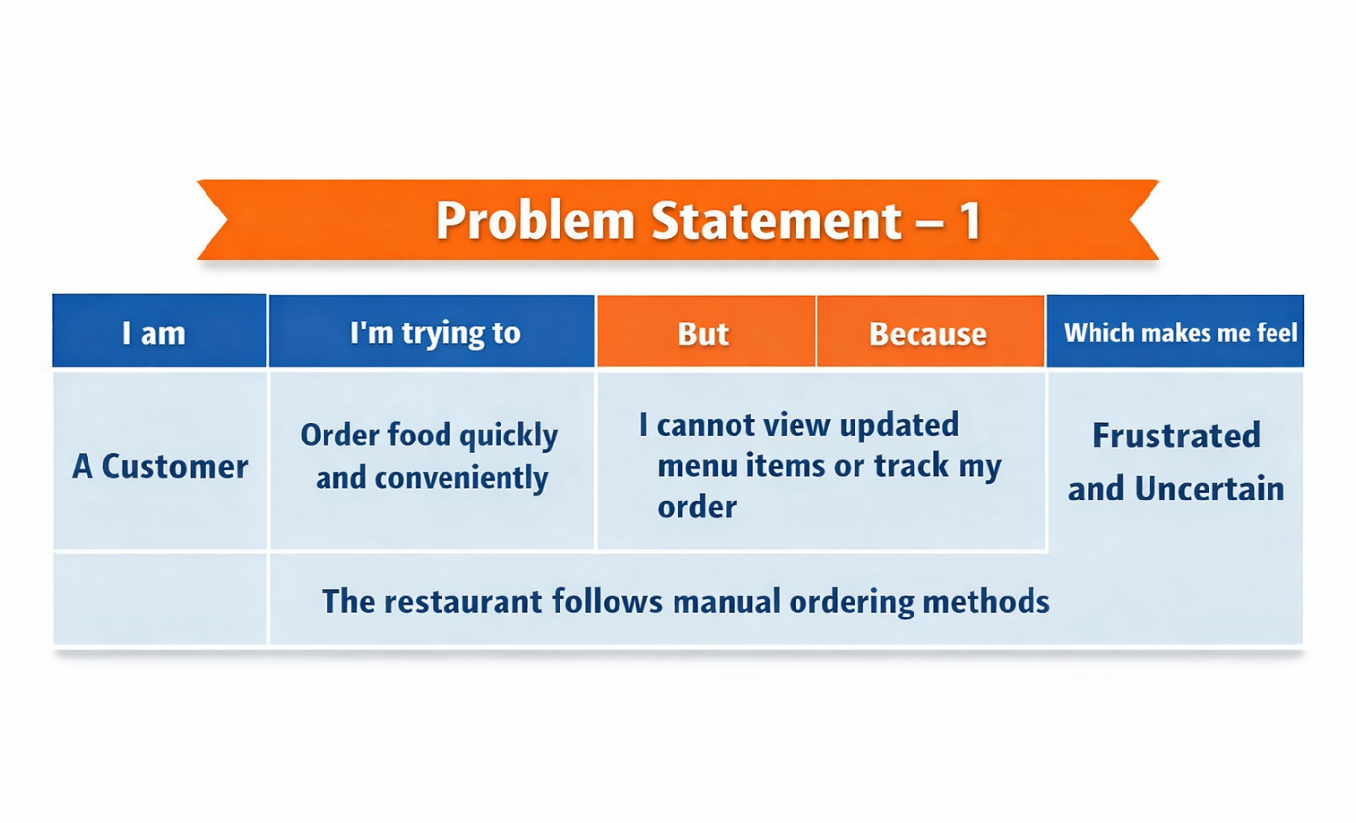

**Problem** **Statement -2:**

|  |  |  |  |  |  |
| --- | --- | --- | --- | --- | --- |
| **Problem Statement (PS)** | **I am** | **I’m trying to** | **But** | **Because** | **Which makes me feel** |
| PS-1 | A Customer | Order food quickly and conveniently | I cannot view updated menu items or track my order | The restaurant follows manual ordering methods | Frustrated and uncertain |
| PS-2 | A Restaurant Admin | Manage daily orders and menu updates efficiently | Orders are recorded manually and scattered | There is no centralized digital system | Overwhelmed and inefficient |

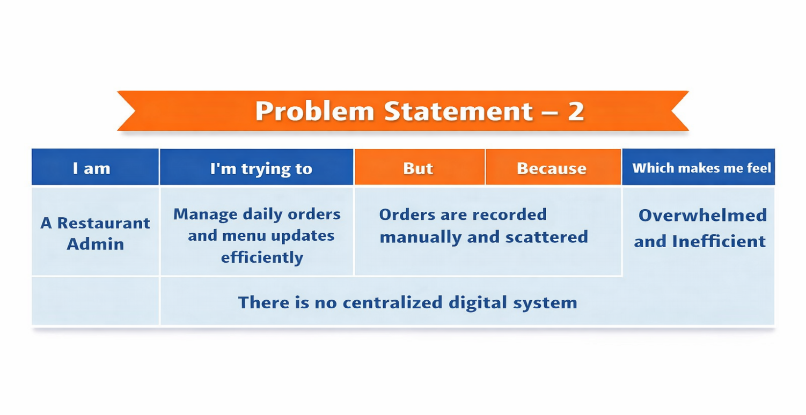

**2.2 Empathy Map:**

**User: - Balaram** -Working Professional (Food Customer)

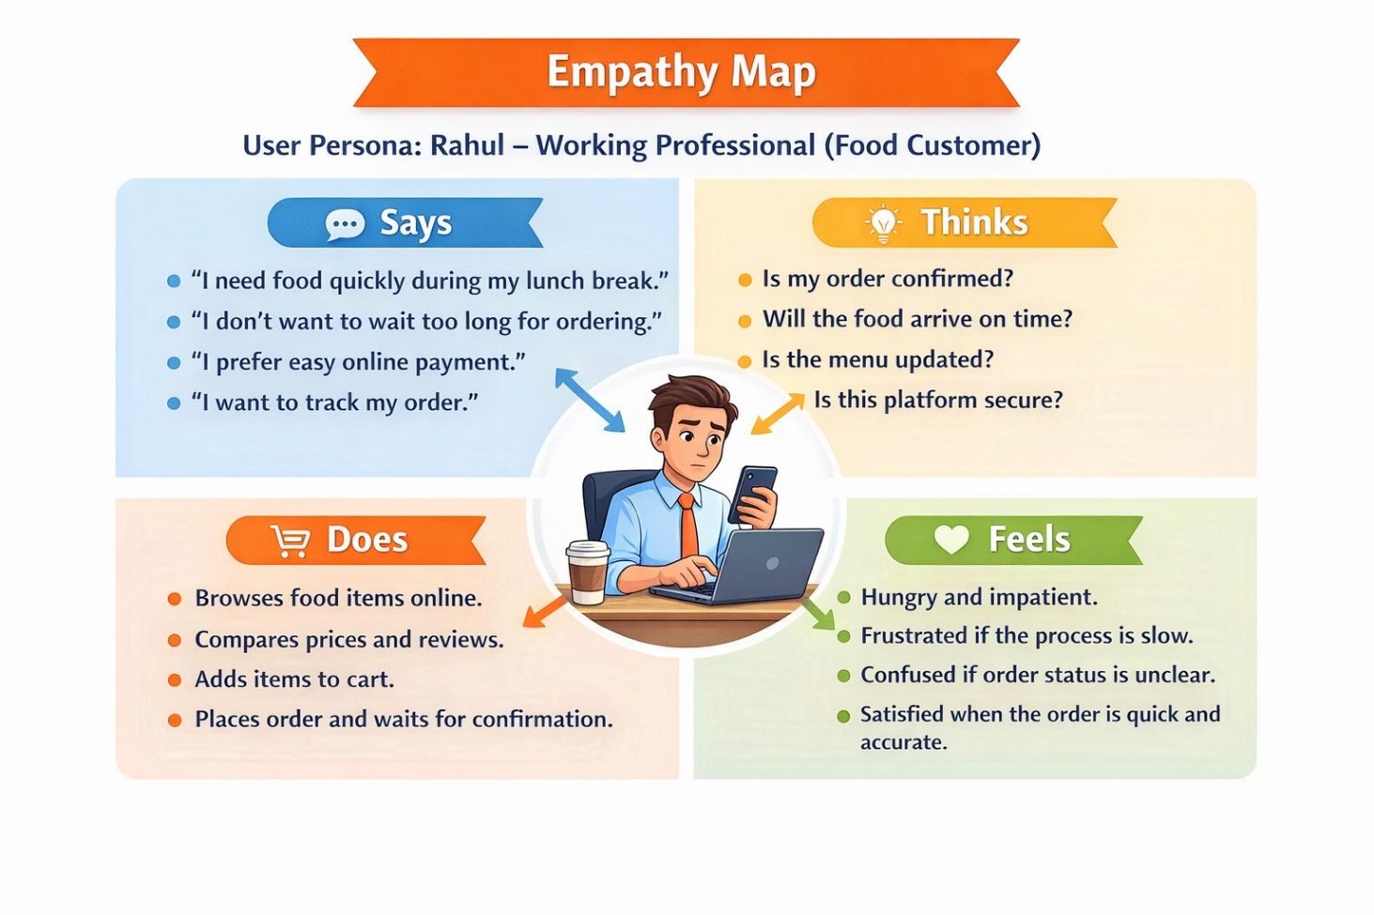

**2.2 Brainstorm & Idea Prioritization:-**

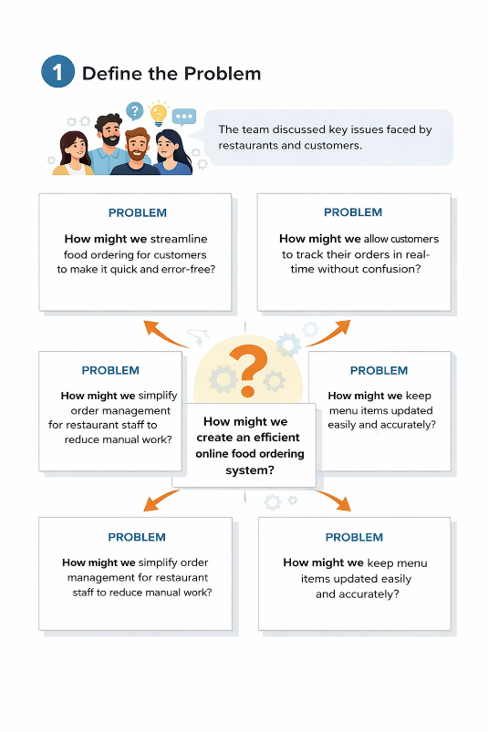**Step-1: Team Gathering, Collaboration and Select the Problem Statement**

**Step-2: Brainstorm, Idea Listing and Grouping**

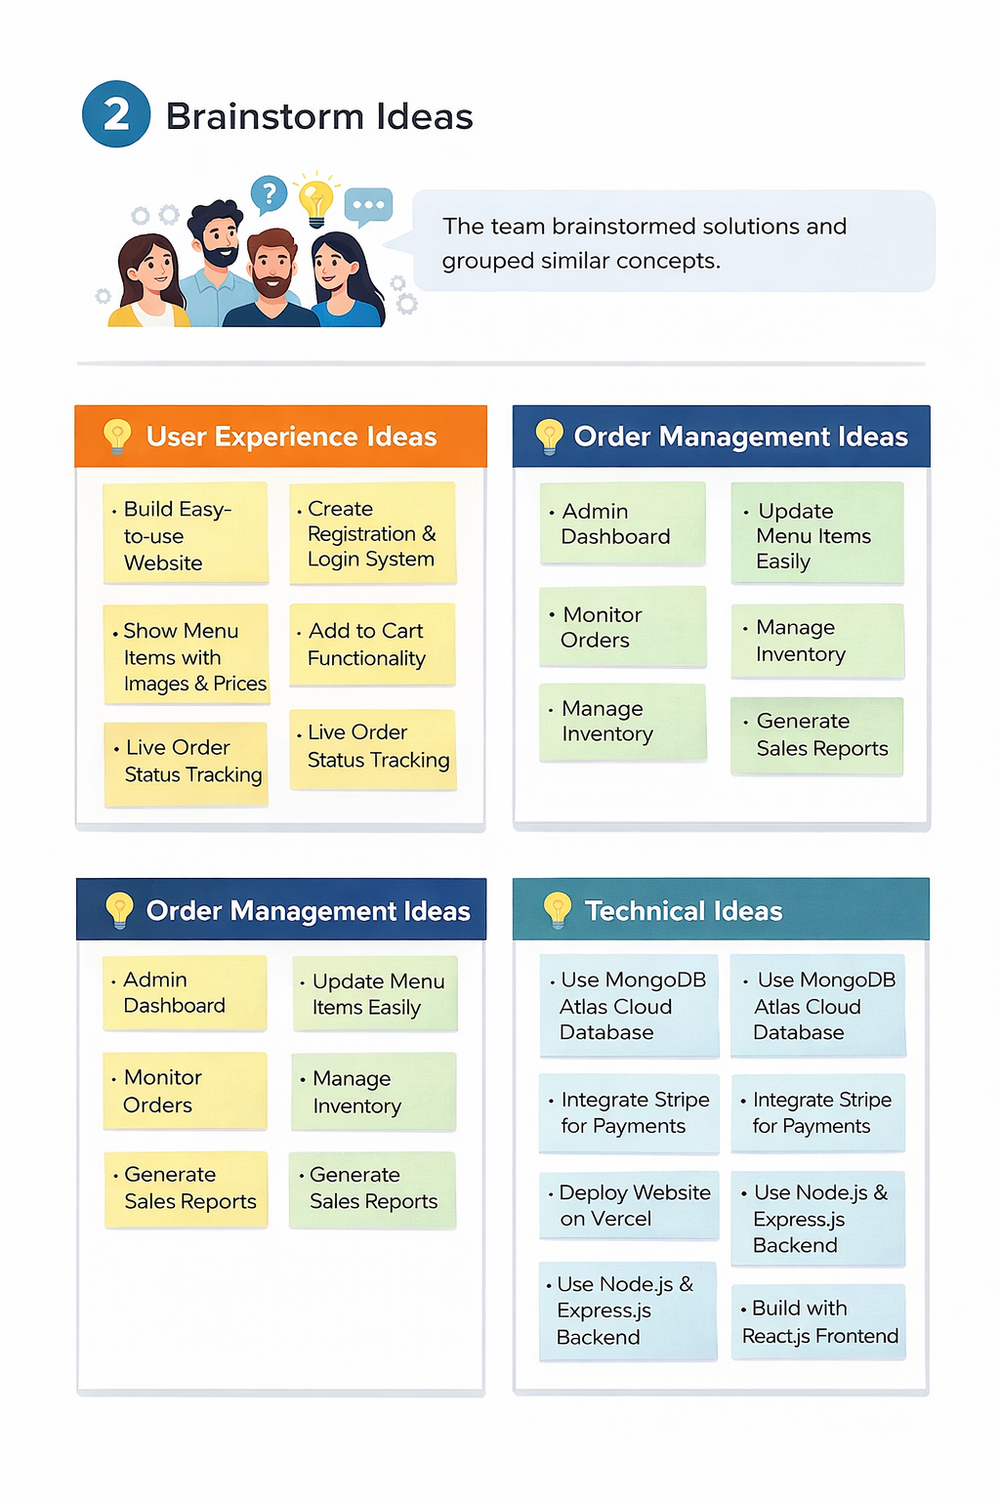

**Step-3: Idea Prioritization**

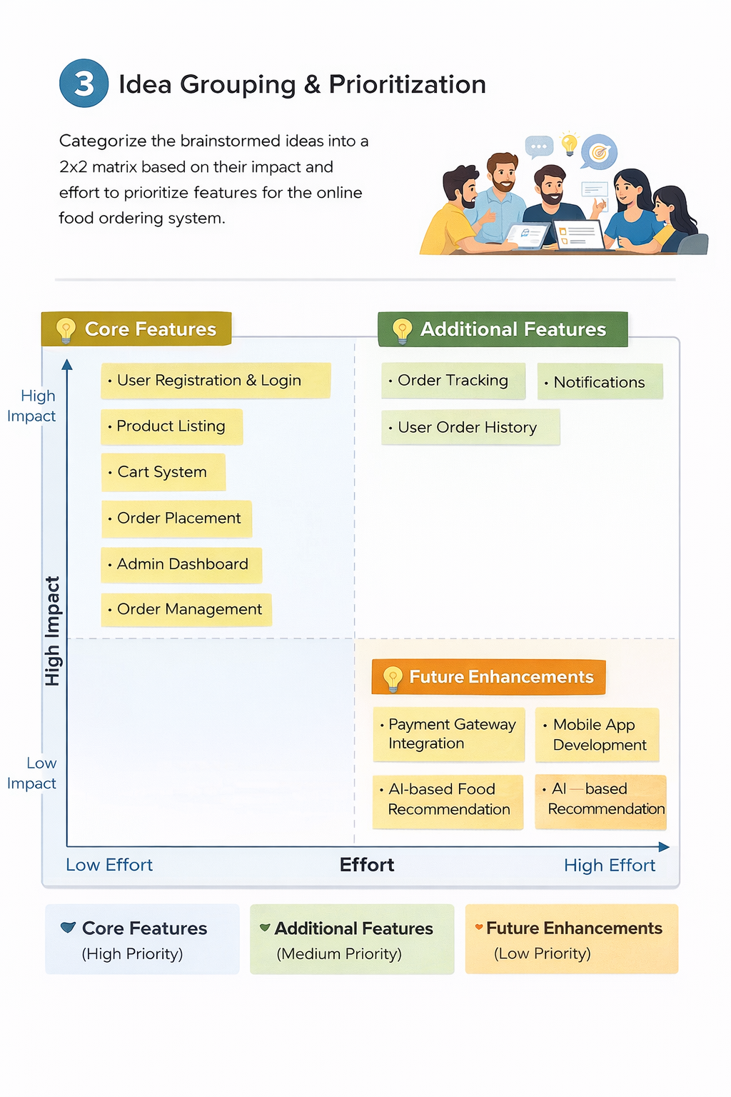

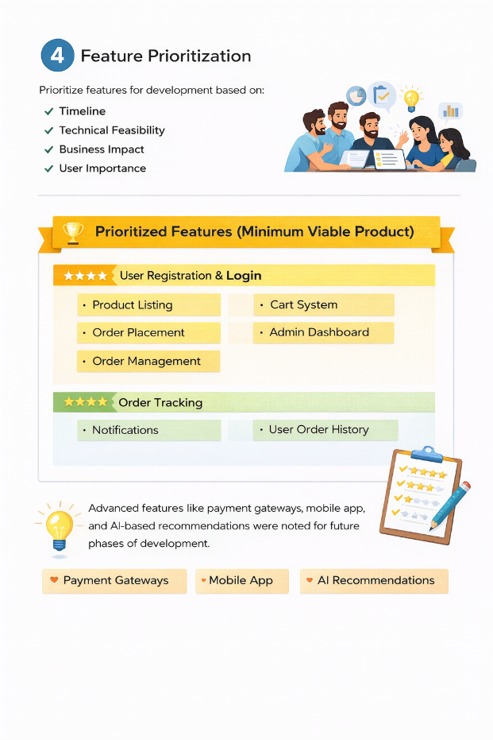

**REQUIREMENT ANALYSIS**

**3.1 Customer Journey map:**

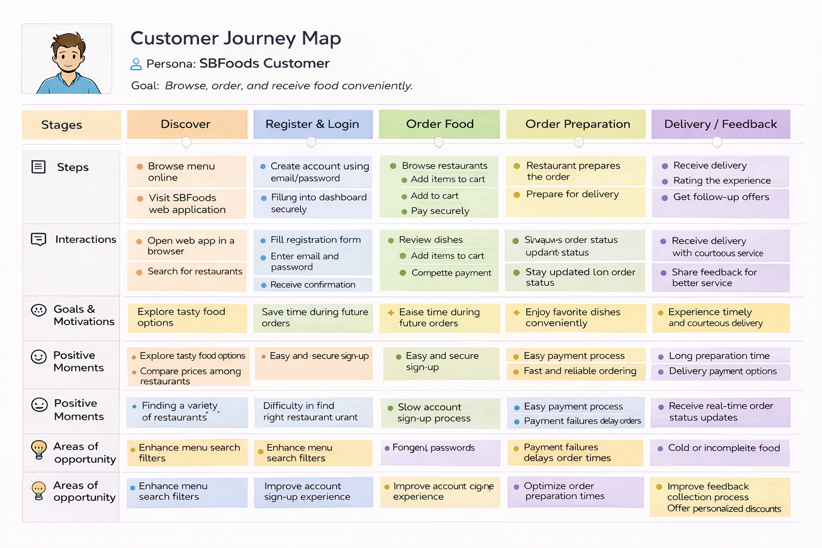

**3.2 Solution Requirement**

**Functional Requirements:**

Following are the functional requirements of the proposed solution.

|  |  |  |
| --- | --- | --- |
| **FR No.** | **Functional Requirement (Epic)** | **Sub Requirement (Story / Sub-Task)** |
| FR-1 | User Registration | |  | | --- | | Users can register using email and password |  |  |  |  | | --- | --- | --- | |  |  | Secure password creation |  |  |  |  | | --- | --- | --- | |  |  | Role selection (Customer / Admin) | |
| FR-2 | User Authentication | Login using Email & Password JWT-based authentication |
| FR-3 | Product Listing | |  | | --- | | View available food items |  |  |  |  | | --- | --- | --- | |  |  | Display product name, image, price, description | |
| FR-4 | Cart Management | |  | | --- | | Add items to cart |   Update quantity / Remove items |
| FR-5 | Order Placement | |  | | --- | | Place food order securely |  |  |  |  | | --- | --- | --- | |  |  | Store order details in database |  |  |  |  | | --- | --- | --- | |  |  | Generate order confirmation | |
| FR-6 | Order Management | |  | | --- | | View order history |  |  |  |  | | --- | --- | --- | |  |  | Track order status (Pending / Preparing / Delivered) | |
| FR-7 | |  | | --- | |  |  |  | | --- | | Admin Dashboard | | |  | | --- | | Add / Edit / Delete food items |  |  |  |  | | --- | --- | --- | |  |  | Manage orders |  |  |  |  | | --- | --- | --- | |  |  | View customer details | |
| FR-8 | Notification System | |  | | --- | | Display order confirmation messages |  |  |  |  | | --- | --- | --- | |  |  | Show order status updates | |

**Non-functional Requirements:**

Following are the non-functional requirements of the proposed solution.

|  |  |  |
| --- | --- | --- |
| **FR No.** | **Non-Functional Requirement** | **Description** |
| NFR-1 | **Usability** | Simple and user-friendly interface allowing patients to book appointments easily without technical knowledge. |
| NFR-2 | **Security** | JWT authentication, encrypted passwords, and secure document upload to protect user data and privacy. |
| NFR-3 | **Reliability** | System ensures accurate appointment scheduling and consistent status updates without data loss. |
| NFR-4 | **Performance** | Fast loading of dashboards and real-time booking actions through efficient API communication. |
| NFR-5 | **Availability** | Platform accessible online anytime for patients, doctors, and admins to manage appointments. |
| NFR-6 | **Scalability** | MongoDB and REST architecture allow future expansion to more users, doctors, and healthcare services. |

**3.3 Data Flow Diagram: -**

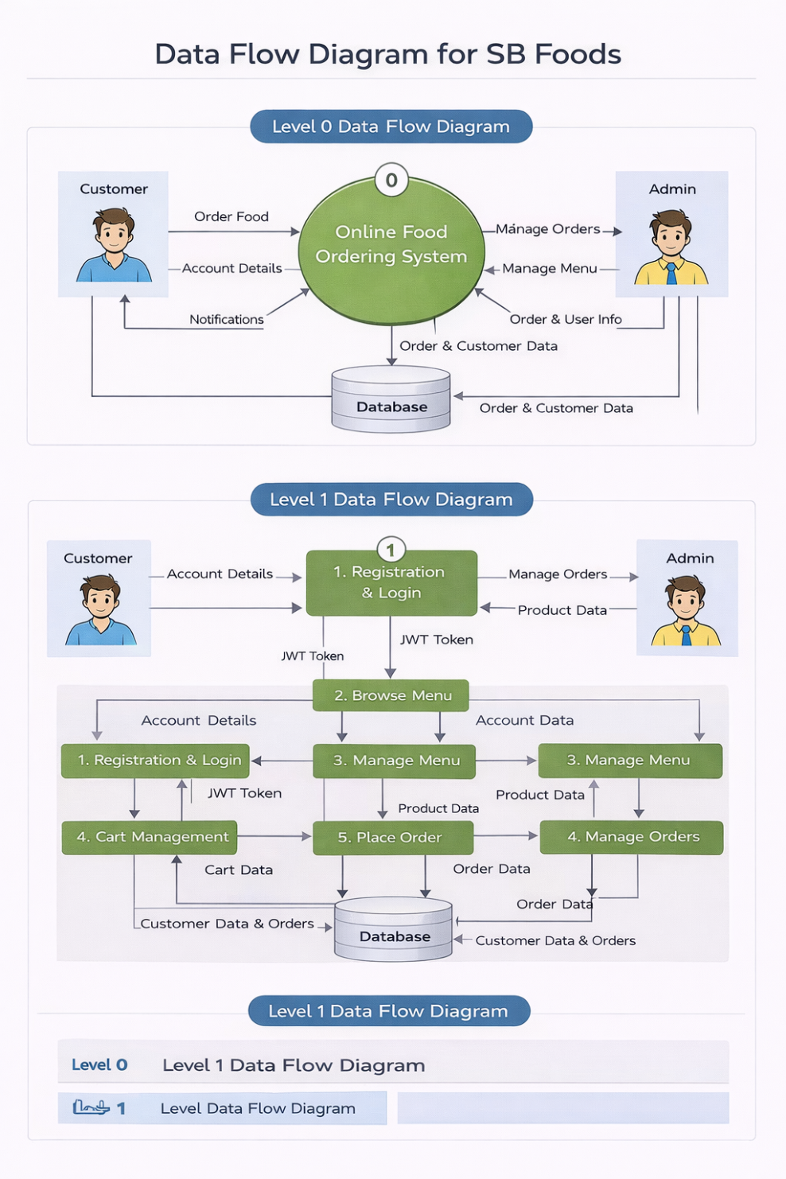

| **User Stories**  **User Type** | **Functional Requirement (Epic)** | **User Story Number** | **User Story / Task** | **Acceptance Criteria** | **Priority** | **Release** |
| --- | --- | --- | --- | --- | --- | --- |
| Customer | Registration | USN-1 | As a user, I can register using email and password | Account is created and user redirected to login/dashboard | High | Sprint-1 |
| Customer | Authentication | USN-2 | As a user, I can log in securely using JWT authentication | Successful login redirects to dashboard | High | Sprint-1 |
| Customer | Product Listing | USN-3 | As a user, I can view available food items | Food items load correctly from database | High | Sprint-1 |
| Customer | Cart Management | USN-4 | As a user, I can add items to cart | Selected item appears in cart with correct quantity | High | Sprint-2 |
| Customer | Cart Management | USN-5 | As a user, I can update or remove items from cart | Cart updates correctly without errors | High | Sprint-2 |
| Customer | Order Placement | USN-6 | As a user, I can place an order | Order is stored in database and confirmation is shown | High | Sprint-2 |
| Customer | Order Tracking | USN-7 | As a user, I can view order status | Order status displays as Pending / Preparing / Delivered | Medium | Sprint-3 |
| Customer | Order History | USN-8 | As a user, I can view my previous orders | Past orders are displayed correctly | Medium | Sprint-3 |
| Admin | Product Management | USN-9 | As an admin, I can add new food items | New product appears in product list | High | Sprint-3 |

**3.4 Technology Stack: -**

**Technical Architecture: -**

The DocSpot application follows a 3-Tier Client–Server Architecture:

* Presentation Layer (Frontend): React.js web interface where users, doctors, and admins interact with the system.
* Application Layer (Backend): Node.js and Express.js handle API requests, authentication, appointment processing, and role-based access control.
* Data Layer (Database): MongoDB stores user profiles, doctor details, appointment records, and notifications.

The frontend communicates with backend REST APIs using Axios, while JWT authentication secures protected routes. File uploads such as medical documents are handled through Multer middleware.

**Table-1: Components & Technologies:**

|  |  |  |  |
| --- | --- | --- | --- |
| **S. No** | **Component** | **Description** | **Technology** |
|  | User Interface | Web interface for patients, doctors, and admin dashboards | React.js, HTML, CSS, Bootstrap, Material UI |
|  | Application Logic-1 | Authentication & Role Management | Node.js, Express.js, JWT |
|  | Application Logic-2 | Appointment Booking & Scheduling | Express.js REST APIs |
|  | Application Logic-3 | Notification & Status Management | Node.js Controllers |
|  | Database | Stores users, doctors, appointments data | MongoDB, Mongoose |
|  | Cloud Database | Cloud-hosted NoSQL database for storing users, doctors, appointments, and notifications with remote access and scalability | MongoDB Atlas |
|  | File Storage | Medical document upload & storage | IBM Block Storage or Other Storage Service or Local Filesystem |
|  | External API-1 | |  | | --- | |  |  |  | | --- | | HTTP communication between frontend & backend | | Axios |
|  | External API-2 | Not Applicable | __ |
|  | Machine Learning Model | Not used in this project | __ |
|  | Infrastructure (Server / Cloud) | Local development deployment | Node.js Local Server |

**Table-2: Application Characteristics:**

| **S. No** | **Characteristics** | **Description** | **Technology** |
| --- | --- | --- | --- |
|  | Open-Source Frameworks | Frameworks used to build UI & Backend APIs | React.js, Express.js, Node.js |
|  | Security Implementations | Role-based authentication, encrypted passwords, protected routes | JWT, bcryptjs, Middleware |
|  | Scalable Architecture | 3-Tier architecture separating UI, backend logic, and database | REST Architecture, MongoDB |
|  | Availability | |  | | --- | |  |  |  | | --- | | Web application accessible anytime through browser | | Node.js Server |
|  | Performance | Fast API responses and asynchronous communication | Axios, Express.js |

**4. PROJECT DESIGN**

**4.1 Problem Solution Fit:**

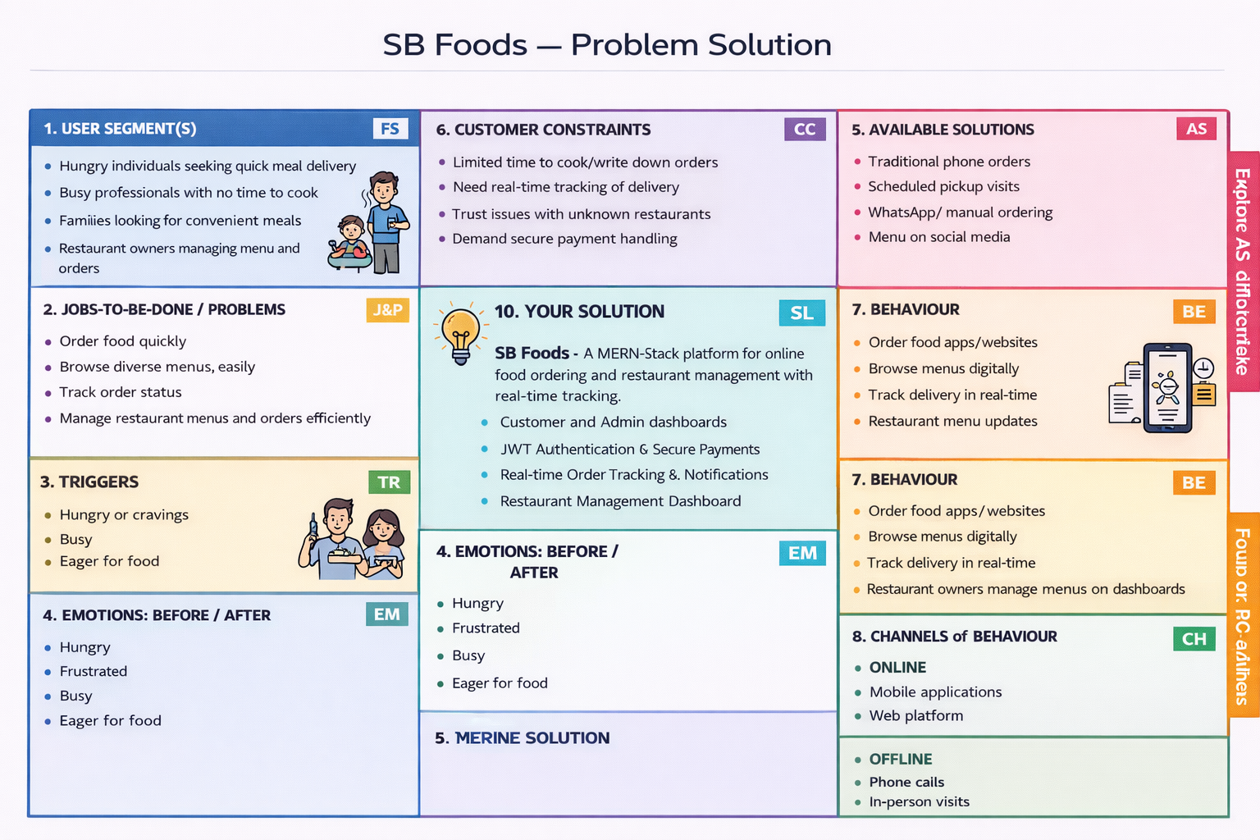

**4.2 Proposed Solution:**

|  |  |  |
| --- | --- | --- |
| **S.No.** | **Parameter** | **Description** |
|  | Problem Statement (Problem to be solved) | Patients face difficulty booking doctor appointments due to manual scheduling, lack of real-time availability, and long waiting times. Doctors need a centralized platform to manage appointments efficiently, while admins require a secure system to verify doctors and maintain platform trust. |
|  | Idea / Solution description | DocSpot is a MERN-stack web application that enables patients to book appointments online through a centralized system. It provides role-based dashboards for Admin, Doctor, and User, real-time booking, secure JWT authentication, document upload, and appointment status tracking using REST APIs connected to MongoDB Atlas. |
|  | Novelty / Uniqueness | Role-based healthcare workflow, admin-controlled doctor approval, real-time appointment tracking, secure medical document upload, and a simplified user-friendly booking interface. |
|  | Social Impact / Customer Satisfaction | Reduces waiting time, improves healthcare accessibility, ensures verified doctor interactions, and enhances patient convenience through digital appointment management. |
|  | Business Model (Revenue Model) | Commission-based booking model, subscription plans for doctors, premium doctor listing, and future telemedicine consultation services. |
|  | Scalability of the Solution | Built using 3-tier architecture (React frontend, Express backend, MongoDB Atlas cloud database), enabling scalable performance and easy expansion to support more users and healthcare services. |

**4.3 Solution Architecture:** 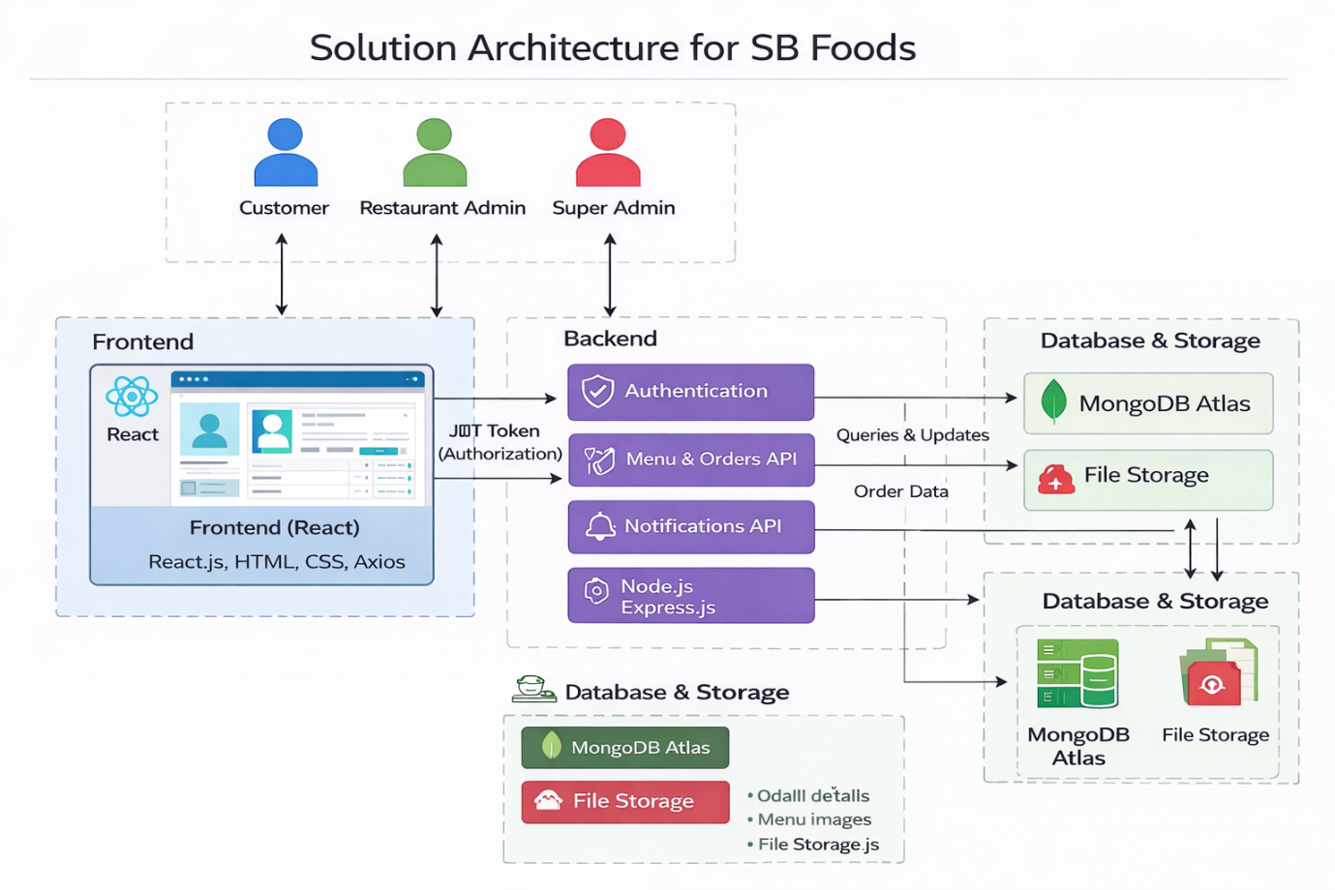

*Figure-1: Architecture and data flow platform*

**5. PROJECT PLANNING & SCHEDULING**

**5.1 Project Planning:**

**Product Backlog, Sprint Schedule, and Estimation :**

| **Sprint** | **Functional Requirement (Epic)** | **User Story Number** | **User Story / Task** | **Story Points** | **Priority** | **Team Members** |
| --- | --- | --- | --- | --- | --- | --- |
| Sprint-1 | |  | | --- | | User Registration | | |  | | --- | | USN-1 | | |  | | --- | | User Registration | | 2 | High | Team |
| Sprint-1 | Authentication | USN-2 | User login with JWT authentication | 2 | High | Team |
| Sprint-1 | Production listing | USN-3 | Display available food items from bashboard | 3 | High | Team |
| Sprint-2 | Cart managemnet | USN-4 | |  | | --- | |  |  |  | | --- | | Add items and update/remove items form cart | | 5 | High | Team |
| Sprint-2 | Order Placement | USN-5 | Place order and store it in database | 3 | Medium | Team |
| Sprint-3 | Order tracking and history | USN-6 | View order status and also view status history | 5 | High | Team |
| Sprint-3 | Product /order management | USN-7 | Admin can add food items and also edit and delete food items  And also admin update order status | 4 | High | Team |
| Sprint-4 | Notifications | USN-8 | Show order confirmation and status messages | 3 | Medium | Team |
| Sprint-4 | UI enhancement | USN-9 | Improve UI resposiveness | 3 | Medium | Team |

**Project Tracker, Velocity & Burndown Chart:**

| **Sprint** | **Total Story Points** | **Duration** | **Sprint Start Date** | **Sprint End Date (Planned)** | **Story Points Completed (as on Planned End Date)** | **Sprint Release Date (Actual)** |
| --- | --- | --- | --- | --- | --- | --- |
| Sprint-1 | 15 | 4 Days | 01 Feb 2025 | 04 Feb 2025 | 15 | 04 Feb 2025 |
| Sprint-2 | 16 | 4 Days | 05 Feb 2025 | 08 Feb 2025 | 16 | 08 Feb 2025 |
| Sprint-3 | 14 | 4 Days | 09 Feb 2025 | 12 Feb 2025 | 14 | 12 Feb 2025 |
| Sprint-4 | 12 | 3 Days | 13 Feb 2025 | 15 Feb 2025 | 12 | 15 Feb 2025 |

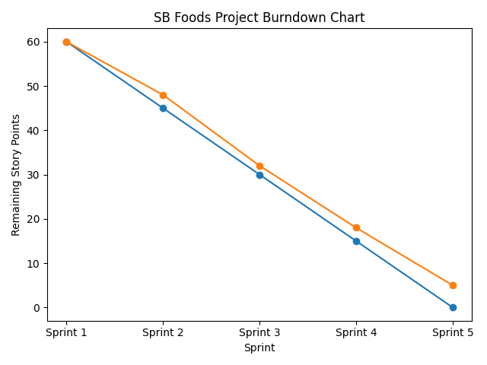

**6. FUNCTIONAL AND PERFORMANCE TESTING**

**6.1 Performance Testing:**

**Project Overview:**

Project Name: OrderOnTheGo: OrderOnTheGo – Online Food Ordering System

OrderOnTheGo – OrderOnTheGo is a MERN-stack web application that enables customers to browse food items, add them to cart, and place orders online with real-time order status tracking. The platform provides role-based dashboards for Customer and Admin, secure JWT authentication, product management features, and order tracking using MongoDB Atlas. The system ensures smooth interaction between frontend and backend APIs for efficient order processing and restaurant management.Project .

Project version:v1.0

Testing Period: 12 Feb 2025 to 15 Feb 2025

**Testing Scope:**

**Features Tested:**

* User Registration & Login
* Role-based Dashboard (Customer & Admin)
* Product Listing (Menu Display)
* Cart Management (Add / Update / Remove Items)
* Order Placement
* Order Status Tracking
* Admin Product Management (Add / Edit / Delete Items)
* Order Status Update by Admin
* Order Confirmation Notifications

**User Stories Tested:**

* USN-1 Registration
* USN-2 Login
* USN-4 Product Listing/ Add to Cart
* USN-5 Order Placement/Order Tracking
* USN-7 Product Management (Admin)
* USN-8 Order Status Update
* USN-9 Notifications

**Testing Environment:**

URL/Location: http://localhost:3000

Credentials (if required): User → hello1@gmail.com / ******  
Owner→ balaram@gmail.com / ******  
Admin → malle@gmail.com / ******

**Test Cases:**

| **Test Case ID** | **Test Scenario** | **Test Steps** | **Expected Result** | **Actual Result** | **Pass/Fail** |
| --- | --- | --- | --- | --- | --- |
| TC-01 | User Registration | 1. Open website 2. Click Register 3. Enter valid details 4. Submit | User account is created successfully | Account created and redirected to login | Pass |
| TC-02 | User Login | 1. Enter valid email & password 2. Click Login | User is redirected to dashboard | Login successful and dashboard displayed | Pass |
| - | Invalid Login | 1. Enter wrong password 2. Click Login | Error message displayed | Error message shown correctly | Pass |
| TC-04 | View Product Listing | 1. Login 2. Navigate to menu page | Food items displayed with name, image, price | Products loaded from database correctly | Pass |
| TC-05 | Add to Cart | 1. Select product 2. Click Add to Cart | Item added to cart successfully | Item appears in cart | Pass |
| TC-06 | Update Cart Quantity | 1. Increase/decrease quantity in cart | Cart updates with correct total price | Quantity updated correctly | Pass |
| TC-07 | Remove Item from Cart | 1. Click Remove button in cart | Item removed from cart | Item removed successfully | Pass |
| TC-08 | Place Order | 1. Add items to cart 2. Click Place Order | Order saved in database and confirmation shown | Order stored and confirmation displayed | Pass |
| TC-09 | Order Status Tracking | 1. Navigate to Order History 2. Check order status | Order status displayed correctly | Status shown as Pending/Preparing/Delivered | Pass |
| TC-10 | Admin Add Product | 1. Login as Admin 2. Add new product 3. Save | Product appears in product list | Product added successfully | Pass |
| TC-11 | Admin Edit Product | 1. Modify product details 2. Save changes | Product updated in system | Product updated correctly | Pass |
| TC-12 | Admin Delete Product | 1. Click Delete on product | Product removed from list | Product deleted successfully | Pass |
| TC-13 | Admin Update Order Status | 1. Change order status 2. Save | Updated status reflected for user | Status updated successfully | Pass |
| TC-14 | Notification Display | 1. Place order 2. Check confirmation message | Order confirmation displayed | Notification shown correctly | Pass |

**Bug Tracking:**

| **Bug ID** | **Bug Description** | **Steps to Reproduce** | **Severity** | **Status** | **Additional Feedback** |
| --- | --- | --- | --- | --- | --- |
| BUG-01 | Cart total price not updating after changing item quantity | Step 1: Login as Customer → Step 2: Add item to cart → Step 3: Increase quantity → Step 4: Observe total price | High | Resolved | Issue fixed by recalculating total price on quantity update in frontend state management |
| BUG-02 | Admin unable to update order status occasionally | Step 1: Login as Admin → Step 2: Navigate to Orders → Step 3: Change status → Step 4: Click Save | Medium | In Progress | Backend API needs validation check for order ID before updating status |

**Sign-off:**

Tester Name: Balaram Muramalla

Date: 15 February 2025

Signature: Muramalla Balaram

**7. RESULTS**

**7.1 Output Screenshots:**

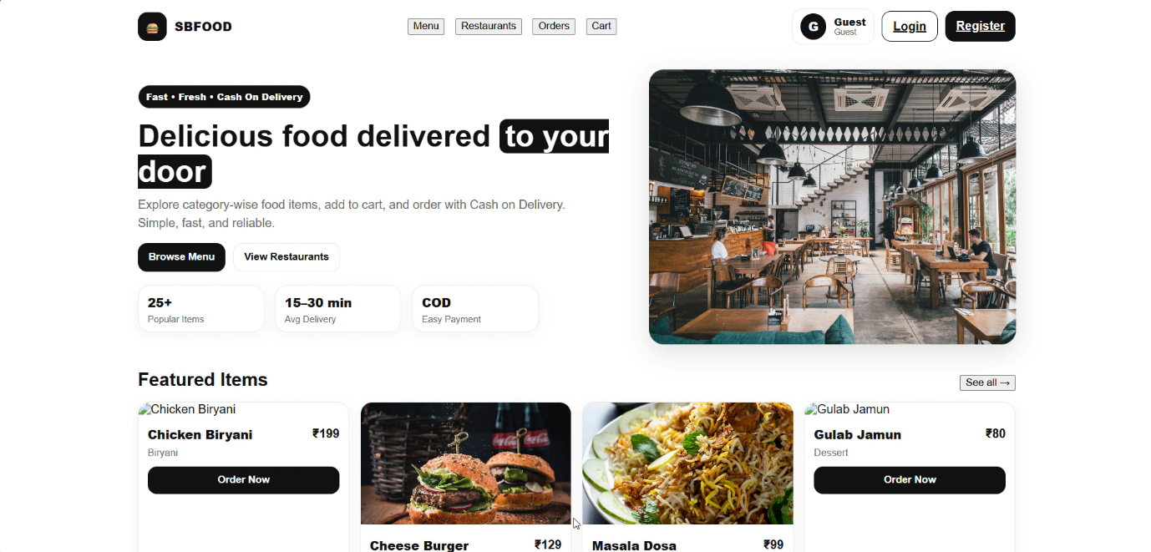

*Figure-2: User Dashboard*

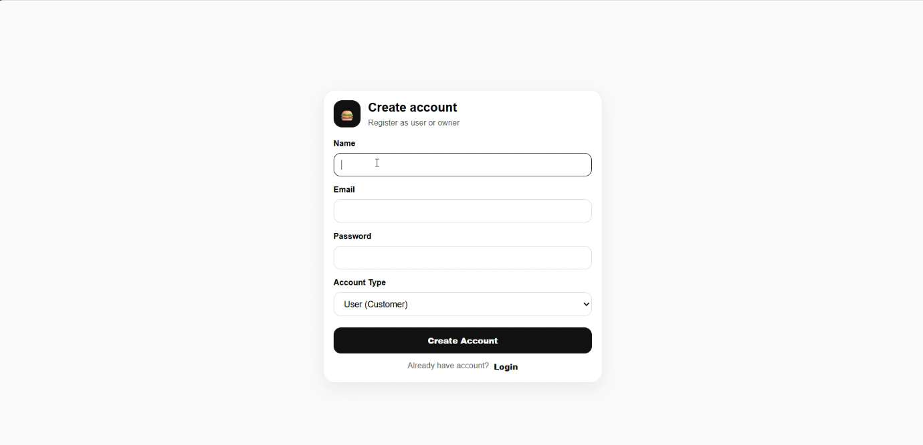

*Figure-3: Creating Account*

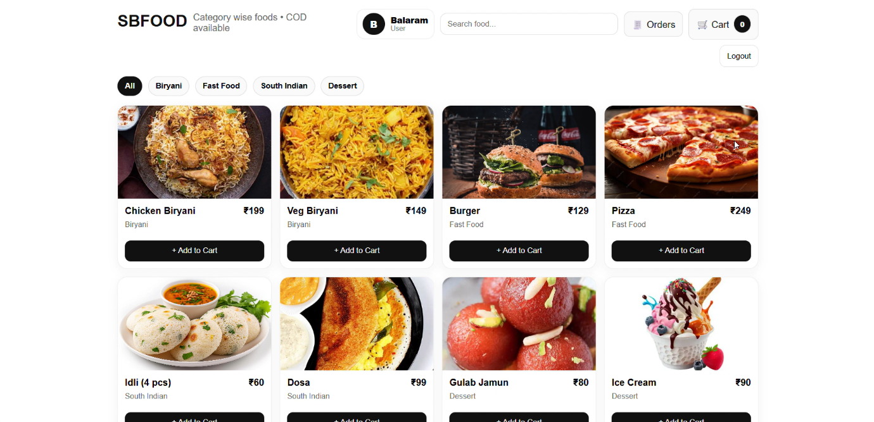

*Figure-4: Menu page*

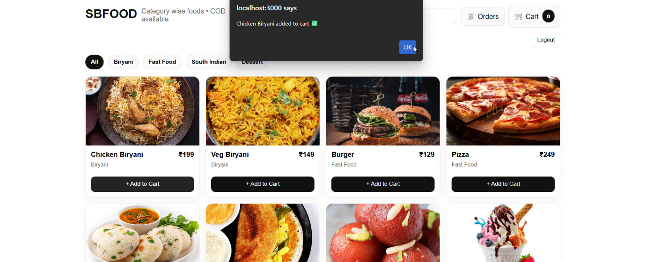

*Figure-5: Add to cart*

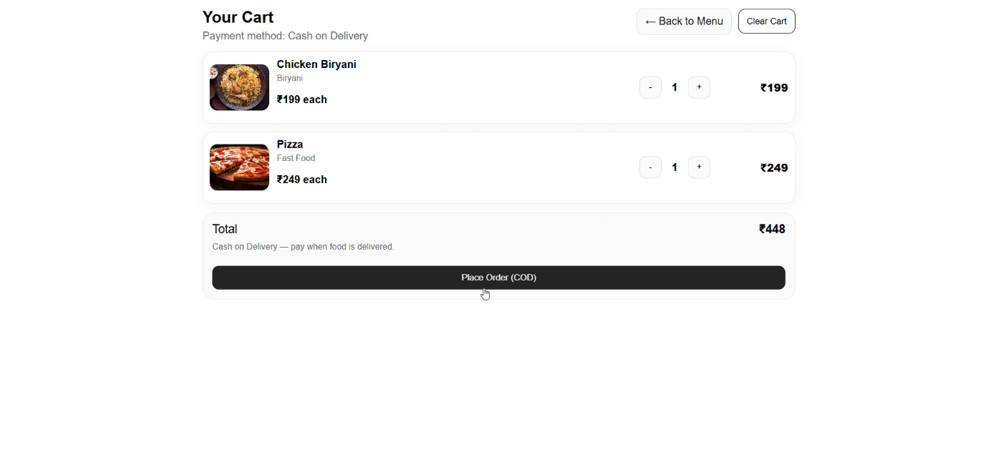*Figure-6: Cart page for ordering items*

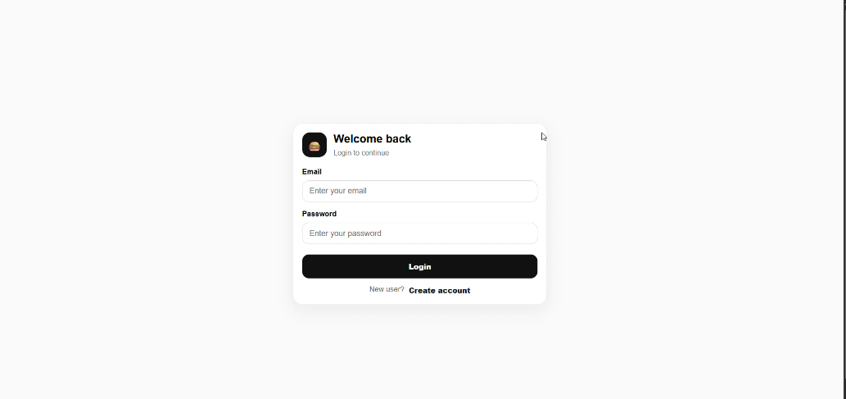

*Figure-7: Login page*

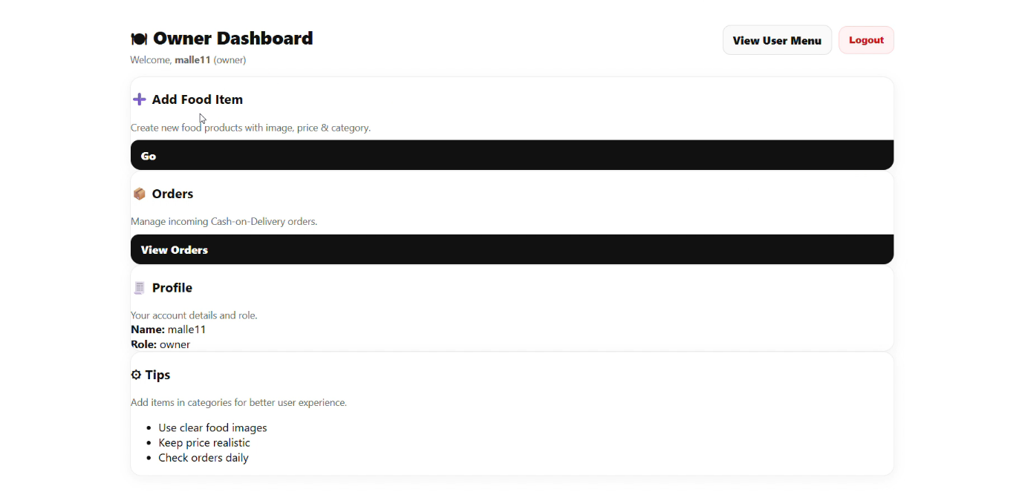

*Figure-8: Omner Dashboard*

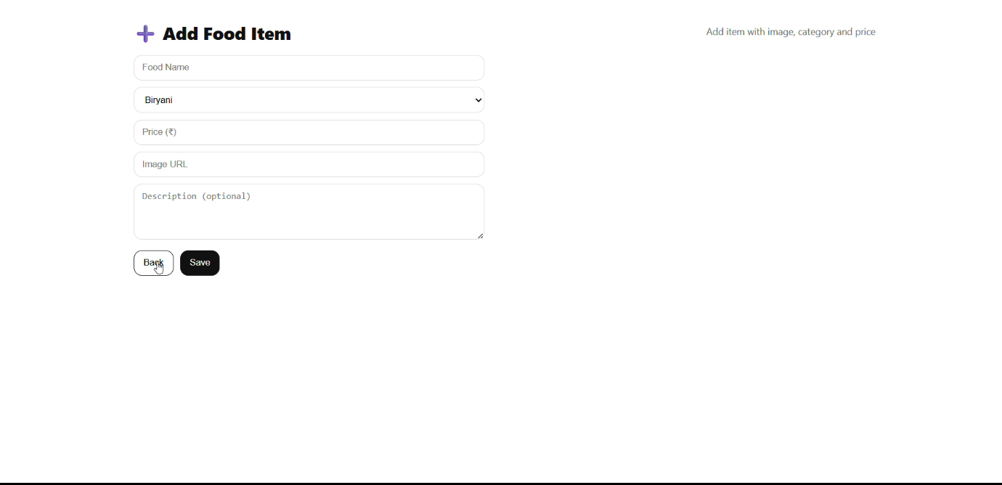

*Figure-8: Add items page*

**8. ADVANTAGES & DISADVANTAGES**

**Advantages**

• Easy Online Ordering: Customers can browse menu items and place orders anytime without visiting the restaurant.

• Time-Saving: Reduces waiting time compared to manual ordering systems.

• Secure Authentication: JWT-based login system ensures data security and protected user access.

• Centralized Management: Admin dashboard allows efficient management of food items and orders.

• Reduced Manual Errors: Digital order storage minimizes billing mistakes and order confusion.

• Cloud Database Integration: MongoDB Atlas provides scalable and secure data storage.

• Order Tracking: Customers can view real-time order status updates.

• User-Friendly Interface: Responsive UI built with React.js improves customer experience.

**Disadvantages**

• Requires stable internet connection to access the platform.

• Currently supports only web-based access (no dedicated mobile application).

• Payment gateway integration is not implemented in the current version.

• Real-time notifications may require further optimization for high traffic.

• System performance may depend on server load and hosting environment.

**9. CONCLUSION**

The OrderOnTheGo – OrderOnTheGo Online Food Ordering System successfully addresses the challenges of traditional manual restaurant ordering methods by providing a centralized digital platform. Using the MERN stack (MongoDB, Express.js, React.js, and Node.js), the system enables customers to browse menu items, manage carts, and place orders securely while allowing administrators to efficiently manage products and monitor orders.

The project demonstrates practical implementation of full-stack development concepts, including RESTful APIs, secure authentication using JWT, database integration with MongoDB Atlas, and responsive frontend design. By reducing manual errors and improving operational efficiency, OrderOnTheGo enhances both customer convenience and restaurant management processes.

Overall, the project provides a scalable and reliable foundation for future enhancements such as payment gateway integration, mobile application development, and real-time delivery tracking.

**10. FUTURE SCOPE**

• Payment Gateway Integration: Integration with online payment systems such as UPI, credit/debit cards, and net banking for secure online transactions.

• AI-Based Food Recommendation System**:** Personalized food suggestions based on user preferences and order history.

• Multiple Restaurant Support**:** Expand the system to support multiple restaurants under one platform.

• Admin Analytics Dashboard**:** Advanced analytics to track sales, popular items, customer trends, and revenue reports.

• Offers & Discount Management**:** Implement coupon codes, promotional offers, and loyalty reward systems.

1. **APPENDIX**

**GitHub Repository:**

<https://github.com/balarammuramalla/OrderOntheGo> **Live Demo / Project Video:**

<https://drive.google.com/file/d/1XRhk4ZJAVnsswxUnsJcOO3eWViHthhW0/view?usp=drivesdk>